**CITIZEN AI-INTELLIGENT CITIZEN ENGAGEMENT PLATFORM**

## Project Description:

Citizen AI is an intelligent citizen engagement platform designed to revolutionize how governments interact with the public. Leveraging Flask, IBM Granite models, and IBM Watson, Citizen AI provides real-time, AI-driven responses to citizen inquiries regarding government services, policies, and civic issues. The platform integrates natural language processing (NLP) and sentiment analysis to assess public sentiment, track emerging issues, and generate actionable insights for government agencies. A dynamic analytics dashboard offers real-time visualizations of citizen feedback, helping policymakers enhance service delivery and transparency. By automating routine interactions and enabling data-driven governance, Citizen AI improves citizen satisfaction, government efficiency, and public trust in digital governance.

**Scenarios:**

**Scenario 1: Real-Time Conversational AI Assistant:**

The Real-Time Conversational AI Assistant in Citizen AI serves as the primary interface for citizen interaction. It allows users to engage with public services naturally by typing questions or requests. The system captures user input in real- time and immediately sends it to a powerful underlying AI model, such as IBM Granite. This model processes the query and generates a relevant, human-like response on the fly. The assistant then displays this response back to the user almost instantly, facilitating quick access to information, support, and the ability to perform tasks like reporting issues, 24/7. It aims to provide a seamless and efficient conversational experience for civic engagement**.**

**Scenario 2: Citizen Sentiment Analysis:**

Citizen Sentiment Analysis in Citizen AI is a core feature designed to understand the public's feelings about government services and related topics.

It works by analysing text input, whether from direct citizen feedback submitted through the platform or potentially from other digital interactions (though the current implementation focuses on submitted text).

Using AI (like the simple analyse_sentiment function in app.py), the system classifies the sentiment of the text as Positive, Neutral, or Negative.

This process helps the government quickly identify areas of public satisfaction or concern. By aggregating sentiment data, the platform provides valuable insights into overall citizen mood and highlights specific issues that may need attention, ultimately aiming to improve service delivery and citizen satisfaction. The results are presented on the dashboard for easy monitoring**.**

**Scenario 3: Dynamic Dashboard:**

The Dynamic Dashboard in Citizen AI serves as a central hub for government officials to gain real-time insights into citizen feedback and interactions. It visualizes key data points, including the overall citizen sentiment (positive, neutral, negative) derived from submitted feedback. The dashboard also tracks interaction trends over time, showing peak periods of activity. Furthermore, it can display aggregated government service ratings or issuesreported by citizens. Bypresenting this information dynamically through charts and clear metrics, the dashboard empowers government departments to quickly understand public perception, identify areas needing improvement, and make data-driven decisions to enhance public services and citizen satisfaction. It transforms raw interaction data into actionable intelligence for a more responsive government**.**

**Scenario 4: Personalized & Contextual Response System:**

Citizen AI features a Personalized & Contextual Response System, powered by IBM Granite models. This system acts as your intelligent chat assistant. Utilizing Granite's advanced natural language understanding (NLU), the platform can accurately interpret citizen queries, understanding the nuance and context of their questions. This capability allows Citizen AI to provide relevant and tailored

responses related to public services and information. The aim is to move beyond generic answers, offering smarter, faster, and more accessible interactions by understanding the specific needs behind each citizen's query and providing information accordingly.

### Technical Architecture:

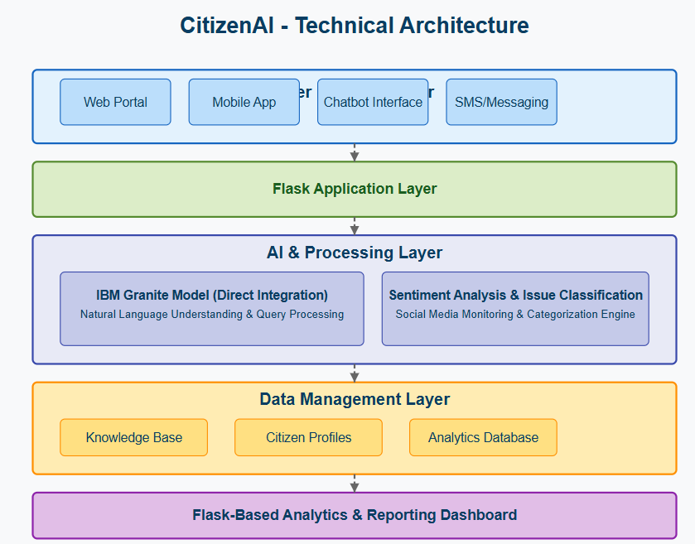

**Pre-requisites:**

### 

### Python: You need a working Python 3.7+ environment installed on your system.

### Gradio: The Gradio framework is required to application.

### Hugging Face Libraries: The transformers, accelerate, and bitsandbytes libraries are essential for loading and utilizing the IBM Granite model, especially with quantization.

### Sufficient Hardware: Running a large language model like IBM Granite

### 3.3B requires significant resources. You will need:

### RAM: A substantial amount of RAM (typically 16GB or more is recommended, even with quantization).

### GPU (Recommended): A compatible NVIDIA GPU with sufficient VRAM (8GB or more is highly recommended, especially for the 8B model, even with 4-bit quantization) and correctly installed CUDA drivers for reasonable inference speed. Running solely on a CPU will be very slow.

### Internet Connection: The first time you run the application, the IBM Granite model files will be downloaded from the Hugging Face Hub. You need an active internet connection for this.

#### Activity 1: Model Selection and Architecture

* **Activity 1.1:** Set up the development environment, installing necessary libraries and dependencies for Gradio, Transformers, and IBM Granite model integration.

#### Activity 2: Core Functionalities Development

* **Activity 2.1:** Integrate the IBM Granite model loading and text generation functionality.
* **Activity 2.4:** Implement helper functions for AI response generation, sentiment analysis, and data formatting.

#### Activity 3: App.py Development

* **Activity 3.1:** Write the main application logic in app.py, establishing functions for each feature and integrating AI responses with the IBM Granite model.

#### Activity 4: Frontend Development

#### Activity 4.1: Create forms for user input (chat, feedback, concern, login) and ensure correct data submission.

#### Activity 5: Deployment

* **Activity 5.1:** Prepare the application for deployment by configuring model loading and memory optimization for the Granite model.
* **Activity 5.2:** Deploy the application on a suitable hosting platform to make it accessible to all citizens.

### Milestone 1: Model Selection and Architecture

#### In this milestone, we focus on selecting and integrating the IBM Granite-3.3-2b-instruct model to power the intelligent conversational capabilities of the Citizen AI platform. This phase involves configuring the model with tailored parameters to ensure accurate, context-aware responses for civic engagement use cases. The integration establishes a robust foundation for delivering multilingual support, summarizing public policies, analyzing citizen sentiments, and enabling real-time, AI-driven interactions for governance, grievance redressal, and personalized citizen services.

#### Activity 1.1: Set up the development environment

1. Install Required Libraries:

bash

pip install gradio transformers torch matplotlib langid accelerate

1. Set Up Application Structure: Create the initial directory structure for the citizen ai application.



### Milestone 2: Core Functionalities Development

#### Activity 2.1: Develop core functionalities

**🔹 1. Real-Time Conversational AI Assistant**

* Conversational interface using IBM Granite via Hugging Face API
* Supports 24/7 citizen queries in natural language
* Multi-language interaction (English, Hindi, Telugu, etc.)
* Text + voice interaction using Speech-to-Text and TTS
* Instant responses for:
  + Government schemes discovery
  + Application steps for documents (Ration card, etc.)
  + Complaints, FAQs, and service guidance
* Automatic routing suggestions for department-specific queries

**🔹 2. Dynamic Citizen Dashboard**

* Personalized user profile: Name, ID, Region, etc.
* Visual overview of:
  + Status of grievances/tickets
  + Notifications from departments (policy updates, alerts)
  + Personalized scheme eligibility recommendations
* Document locker: Aadhaar, PAN, Voter ID (secure storage)
* Real-time activity and sentiment trend graphs

**🔹 3. Citizen Sentiment Analysis Engine**

* Analyzes submitted feedback (from forms, chat, etc.)
* Supports text-level polarity classification: Positive / Neutral / Negative
* Region-wise heatmaps of public dissatisfaction
* Tracks overall public mood to improve services
* Dashboards for officials to monitor emerging issues

**🔹 4. Feedback & Grievance Redressal System**

* Submit complaints with category auto-detection (roads, sanitation, etc.)
* Upload images/videos for better context
* AI-powered auto-routing to respective municipal bodies
* SLA escalation tracking with status updates
* SMS/email notifications for ticket progress

**🔹 5. AI-Powered Policy Summarizer**

* Extract and summarize government policies or legal content
* Explain policies in simple regional language
* Provide “What this means for you” summaries
* Supports visuals and real-world analogies for better comprehension

**🔹 6. Local Government Notifications & Alerts**

* Push notifications for:
  + Region-specific alerts (flood, road blockages, water cuts)
  + Health advisories, vaccination drives
  + Emergency weather alerts
* Custom delivery based on user profile/region

**🔹 7. Participatory Governance Tools**

* Polls and opinion gathering for:
  + Public infrastructure design (e.g. “Choose park layout”)
  + Budget allocation preference (Participatory Budgeting)
* Forums for citizen discussions
* Upvote/downvote based feedback voting

**🔹 8. Personalized Citizen Services Portal**

* AI-guided chat-style interface for:
  + Ration card application
  + Pension eligibility check
  + Birth/death/income certificate application
* Step-by-step guides with contextual prompts

**🔹 9. Integration with Govt APIs / Databases**

* Digilocker for document access and storage
* Aadhaar authentication via UIDAI API
* Municipal complaint system sync (city-wise)
* Property database lookup
* Integration with NDHM for health records

**🔹 10. Generative AI Utilities**

* Auto-generate:
  + Complaint letters
  + RTI drafts
  + Petitions
  + Application forms (auto-filled based on user profile)
* Formal/informal tone adjustment tool for citizen communication

**🔹 11. Inclusivity & Accessibility**

* Screen reader and keyboard navigation support
* Voice input for elderly and differently-abled citizens
* Large text, color contrast toggle, and simplified layouts
* Regional language support with toggle
* Offline kiosk-compatible UI for rural deployment

**🔹 12. Admin Panel for Authorities**

* Dashboards with:
  + Complaint volume and resolution time
  + Citizen sentiment trends over time
  + Region-wise top complaint categories
* AI-generated improvement suggestions
* Word clouds for common feedback themes

#### Activity 2.2: Implement data management utilities

1. **User Profile Management**

* Store user information (name, region, Aadhaar ID, language preference)
* Update and retrieve citizen profiles
* Enable personalized services based on user data

2. **Grievance Data Handling**

* Register new complaints with auto-generated ticket ID
* Store complaint category, description, media (images/videos), and timestamps
* Track complaint status (e.g., Open, In Progress, Resolved)

3. **Sentiment Feedback Storage**

* Save feedback submitted by users
* Store sentiment classification (Positive, Neutral, Negative)
* Enable sentiment trend analysis over time and region

4. **Chat Interaction Logging**

* Log AI chat conversations for accountability and personalization
* Store user query, AI response, timestamp, and user ID
* Useful for improving AI accuracy and training data

5. **Notification Management**

* Store and manage region-specific or user-specific notifications
* Push government alerts (e.g., water outage, public policy updates)
* Track delivery status and timestamps

6. **Policy Summary Storage**

* Save AI-generated summaries of government policies
* Include metadata like title, region, language, and date
* Enable quick retrieval for user-specific policy explanations

7. **Data Export & Aggregation Utilities**

* Generate reports in CSV/JSON for admin dashboard
* Aggregate complaint data, sentiment data, and interaction logs
* Support visualization in the Dynamic Dashboard module

8. **Database Structure**

* Modular SQLite database (for easy use in Google Colab/Gradio)
* Tables include: users, grievances, feedback, notifications, chat_logs, policies
* Scalable to PostgreSQL or MongoDB for production

9. **Security & Validation**

* Basic input validation for form fields (ID, Aadhaar, Email)
* Prepared statements to prevent SQL injection
* Optional encryption for sensitive data (e.g., Aadhaar)

### Milestone 3: App.py Development

#### Activity 3.1: Write the main application logic

**1. Imports and Setup:**

* Import essential libraries (Gradio, Pandas, Plotly, TextBlob, Transformers, Torch)
* Load IBM Granite-3.0-2b-instruct model with optimized configuration for Colab
* Initialize tokenizer and model with CUDA/CPU device mapping and 8-bit quantization
* Set up global data storage variables for user data, complaints, feedback, and chat history
* Configure torch optimization settings for memory efficiency

**2. Core AI Functions:**

* generate_with_local_model(): Handle AI text generation using the local Granite model with proper prompt formatting
* analyze_sentiment(): Perform sentiment analysis using TextBlob for citizen feedback classification
* conversational_ai_assistant(): Main chatbot interface with context-aware prompt engineering
* cleanup_memory(): GPU memory management and garbage collection for optimal performance
* initialize_sample_data(): Populate system with demonstration data for immediate functionality

**3. Citizen Services Functions:**

* submit_feedback(): Process and analyze citizen feedback with automatic sentiment detection
* register_complaint(): Handle complaint registration with unique ID generation and status tracking
* get_user_profile(): Create and manage citizen profiles with regional information
* get_notifications(): Retrieve and display latest government notifications and alerts
* get_service_guide(): Provide step-by-step guides for various government services

**4. AI-Powered Document Generation:**

* generate_policy_summary(): Create citizen-friendly summaries of government policies using local AI
* generate_document_draft(): Generate RTI applications, complaint letters, and application forms
* create_sentiment_dashboard(): Build interactive sentiment analysis visualizations
* create_complaint_status_chart(): Generate complaint tracking and status analytics

**5. UI Components and Interface:**

* Tabbed interface using Gradio Blocks with 9 comprehensive sections
* create_main_interface(): Main interface constructor with responsive design
* Custom styling with gradient headers and professional government theme
* Real-time chat interface with conversation history management
* Interactive dashboards with Plotly integration for data visualization

**6. Government Service Modules:**

* 🤖 AI Assistant: Real-time conversational AI for citizen queries
* 👤 Citizen Dashboard: Personalized profile and notification management
* 📝 Feedback & Complaints: Dual-system for feedback submission and complaint registration
* 📊 Analytics Dashboard: Live sentiment analysis and complaint status monitoring
* 🏛️ Services Guide: Comprehensive guides for Ration Card, Birth Certificate, Pension, etc.

**7. Advanced Features Implementation:**

* 📋 Policy Summarizer: AI-powered policy document analysis and simplification
* 📄 Document Generator: Automated generation of government application documents
* 🗳️ Participatory Governance: Public polling and discussion forum system
* ⚙️ Admin Panel: Government official dashboard with complaint management and broadcasting

**8. Data Management and Analytics:**

* In-memory data storage system for demonstration purposes
* Real-time analytics with sentiment tracking and complaint status monitoring
* User profile management with regional categorization
* Notification system with categorized alerts (info, warning, alert)
* Interactive data visualization using Plotly for government insights

**9. Platform Configuration and Deployment:**

* Google Colab optimization with automatic package installation
* Flexible model loading with CPU/GPU fallback mechanisms
* Public link generation for accessibility and sharing
* Error handling and graceful degradation when AI model unavailable
* Multi-threaded server configuration for concurrent user support

**Activity 3.2: Create prompting strategies for Citizen AI Platform**

**Real-Time AI Assistant Prompting:**

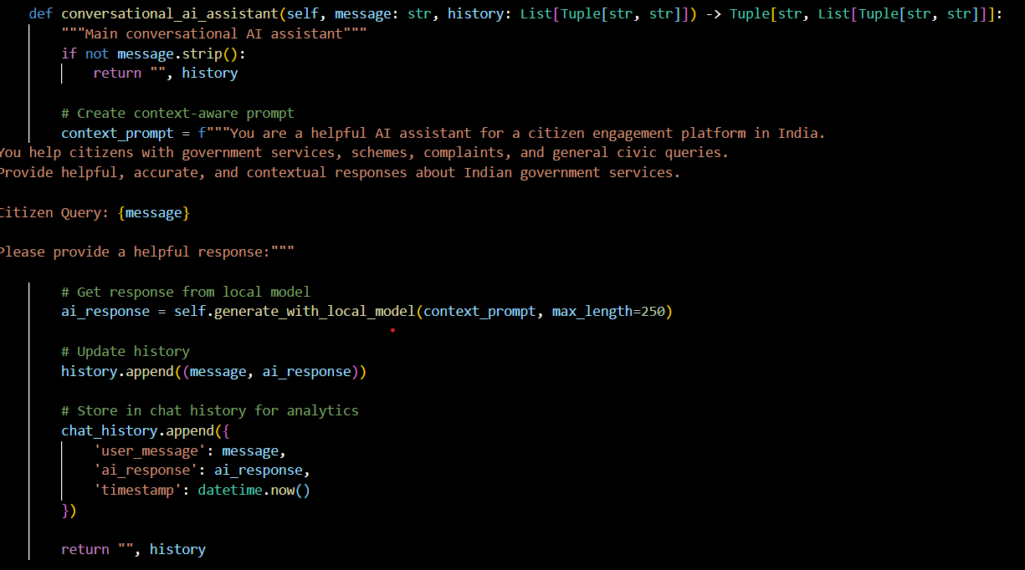

**Policy Analysis Prompting:**

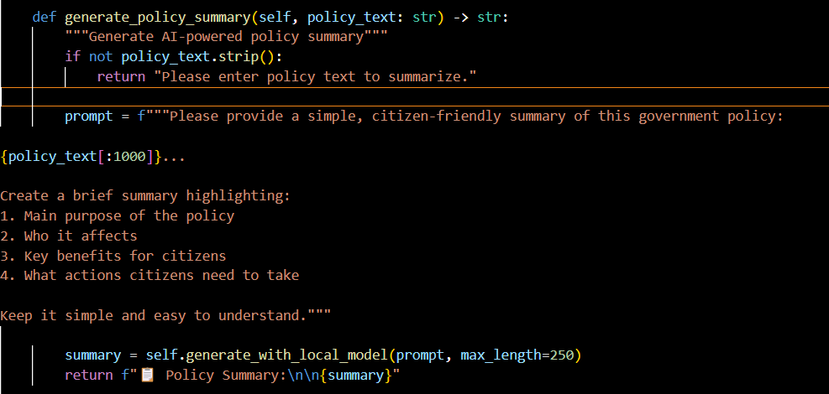

**Document Generation Prompting:**

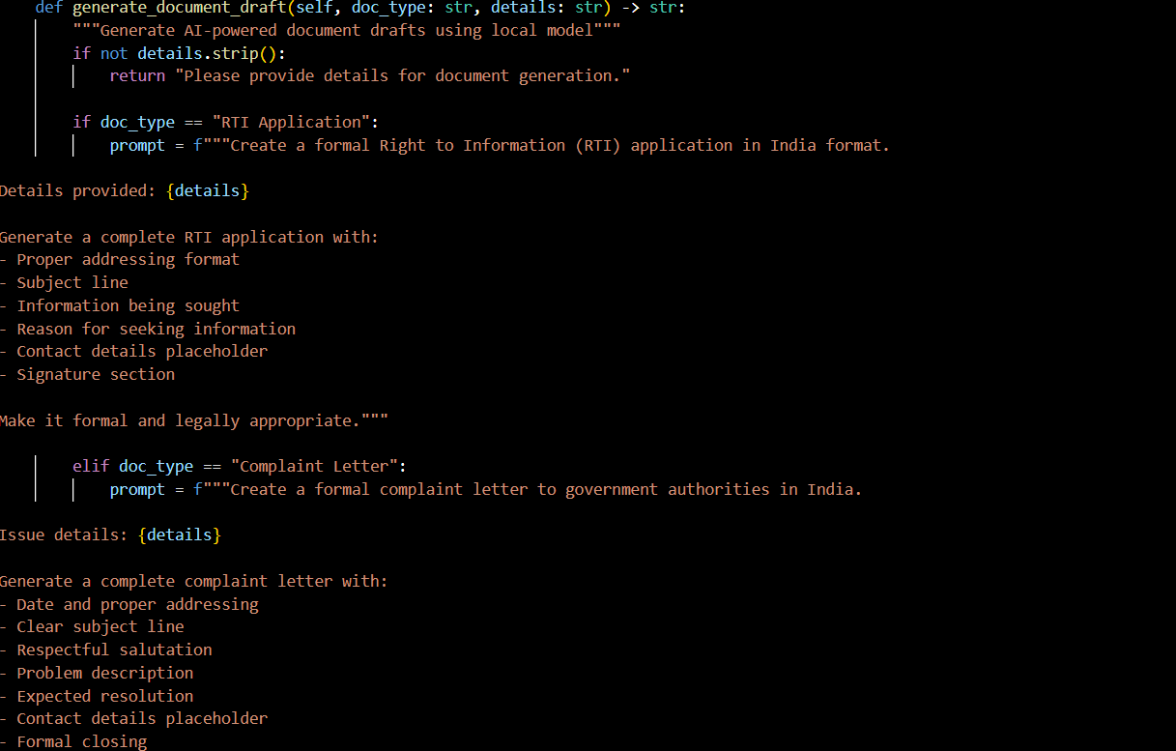

## 

## Milestone 4: Frontend Development

## Activity 4.1: Design and develop the user interface

## 1.Main Application Layout:

* **Gradio Blocks Configuration:** Configure main Gradio interface with "Citizen AI - Intelligent Citizen Engagement Platform" branding
* **Header Design:** Implement gradient header with platform title, description, and AI model status indicator
* **Tabbed Navigation:** Create 9-tab navigation system for comprehensive feature access:
  + 🤖 AI Assistant
  + 👤 Citizen Dashboard
  + 📝 Feedback & Complaints
  + 📊 Analytics Dashboard
  + 🏛️ Services Guide
  + 📋 Policy Summarizer
  + 📄 Document Generator
  + 🗳️ Participatory Governance
  + ⚙️ Admin Panel
* **Responsive Layout:** Implement row/column structure with proper scaling and responsive design
* **Theme Integration:** Apply Gradio Soft theme for consistent visual appearance

**2. Feature-Specific Interfaces:**

**AI Assistant Tab:**

* **Chatbot Interface:** Real-time conversational interface with 400px height and custom placeholder
* **Message Input System:** Text input with send button and submit functionality
* **Memory Management:** GPU memory cleanup controls and model status display
* **Conversation History:** Persistent chat history with timestamp tracking

**Citizen Dashboard Tab:**

* **Profile Management:** Name, Citizen ID, and region selection dropdowns
* **Notification System:** Real-time notifications display with refresh functionality
* **User Data Storage:** Profile creation and update with validation
* **Regional Services:** Location-based service customization

**Feedback & Complaints Tab:**

* **Dual-Column Layout:** Separate sections for feedback submission and complaint registration
* **Feedback System:** Multi-line text input with sentiment analysis integration
* **Complaint Management:** Category dropdown with detailed description fields
* **Status Tracking:** Automated complaint ID generation and tracking system

**Analytics Dashboard Tab:**

* **Visualization Components:** Interactive Plotly charts for sentiment and complaint analysis
* **Real-time Updates:** Dynamic chart refresh functionality
* **Data Visualization:** Pie charts for sentiment distribution and bar charts for complaint status

**Services Guide Tab:**

* **Service Selection:** Dropdown menu for government services (Ration Card, Birth Certificate, etc.)
* **Step-by-step Guides:** Comprehensive service application procedures
* **Contact Information:** Relevant department contact details integration
* **Document Requirements:** Clear listing of required documents for each service

**Policy Summarizer Tab:**

* **AI-Powered Processing:** Large text input area for policy document pasting
* **Summary Generation:** IBM Granite model integration for policy simplification
* **Citizen-Friendly Output:** Structured summaries with key points highlighting
* **Model Status Integration:** Conditional functionality based on AI model availability

**Document Generator Tab:**

* **Document Type Selection:** Dropdown for RTI Applications, Complaint Letters, Application Forms
* **Detail Input System:** Multi-line text input for document specifics
* **AI Generation:** Local model integration for document creation
* **Template Formatting:** Professional document structure with placeholders

**Participatory Governance Tab:**

* **Public Polling System:** Interactive checkbox groups for citizen voting
* **Discussion Forum:** Comment submission with moderation workflow
* **Topic Management:** Dynamic discussion topic display
* **Engagement Tracking:** Vote counting and comment management

**Admin Panel Tab:**

* **Statistics Dashboard:** Real-time platform usage metrics display
* **Notification Broadcasting:** System-wide message distribution controls
* **Complaint Management:** Tabular view with status update functionality
* **User Management:** Profile monitoring and administration tool

**Milestone 5: Deployment - Citizen AI Platform**

#### Activity 5.1: Prepare for deployment

## 1.Model Configuration:

* **IBM Granite Model Setup:** Configure IBM Granite 3.0-2B model loading with proper device mapping
* **Device Optimization:** Implement CUDA/CPU detection with automatic device assignment
* **Memory Management:** Set up 8-bit quantization for GPU memory optimization and float16 precision
* **Model Loading Strategy:** Implement fallback mechanism from GPU to CPU with error handling
* **Tokenizer Integration:** Configure AutoTokenizer with proper special token handling and padding
* **Generation Parameters:** Set optimal temperature (0.7), top_p (0.9), and repetition penalty (1.1) for quality responses

**2. Dependency Management:**

* **Create requirements.txt file with all necessary packages:**
* gradio>=4.0.0
* pandas>=1.5.0
* plotly>=5.15.0
* textblob>=0.17.1
* numpy>=1.21.0
* python-dateutil>=2.8.2
* transformers>=4.35.0
* torch>=2.0.0
* accelerate>=0.20.0

bitsandbytes>=0.41.0

* **Version Pinning:** Ensure compatibility between transformers, torch, and accelerate versions
* **Optional Dependencies:** Configure conditional imports for GPU-specific packages
* **System Requirements:** Document minimum Python version (3.8+) and system specifications

**3. Environment Configuration:**

* **Google Colab Setup:** Configure pip installation commands for Colab environment
* **GPU Memory Allocation:** Set up proper GPU memory management and cleanup procedures
* **Model Caching:** Configure Hugging Face model cache for efficient re-loading
* **Error Handling:** Implement comprehensive exception handling for model loading failures

**4. Data Structure Initialization:**

* **Global Storage Setup:** Initialize user_data, complaints, feedback_data, and notifications dictionaries
* **Sample Data Loading:** Populate platform with demonstration data for immediate functionality
* **Session Management:** Configure in-memory data persistence for user sessions
* **Data Validation:** Implement input validation and sanitization for all user inputs

**Activity 5.2: Deploy the application**

**1. Local Deployment Testing:**

* **Application Startup:** Run the application using the main() function with proper error handling
* **Model Loading Verification:** Test IBM Granite model initialization and fallback mechanisms
* **Interface Testing:** Verify all 9 tabs load correctly with proper functionality:
  + AI Assistant conversational interface
  + Citizen Dashboard profile management
  + Feedback & Complaints submission system
  + Analytics Dashboard visualization rendering
  + Services Guide information retrieval
  + Policy Summarizer AI processing
  + Document Generator template creation
  + Participatory Governance polling system
  + Admin Panel management controls
* **Feature Integration Testing:** Validate AI model responses, sentiment analysis, and document generation
* **Memory Management:** Test GPU memory cleanup and garbage collection functionality

**2. Google Colab Deployment:**

* **Public Link Generation:** Configure Gradio share=True for public accessibility
* **Server Configuration:** Set up server_name="0.0.0.0" and server_port=7860 for Colab compatibility
* **Queue Management:** Enable queue system with max_threads=4 for concurrent user handling
* **Resource Monitoring:** Monitor GPU usage and memory consumption during operation
* **Fallback Testing:** Verify application functionality when GPU resources are unavailable

**3. Cloud Deployment Options:**

**Hugging Face Spaces Deployment:**

* **Space Creation:** Set up new Gradio Space with appropriate hardware configuration
* **GPU Space Setup:** Configure T4 or A10G GPU for optimal IBM Granite model performance
* **Environment Variables:** Set up model caching and authentication if required
* **Automatic Deployment:** Configure git-based deployment with requirements.txt
* **Public Access:** Enable public space for citizen accessibility

**Google Cloud Platform Deployment:**

* **Compute Engine Setup:** Configure VM instance with GPU for model hosting
* **Container Deployment:** Create Docker container with all dependencies
* **Load Balancer Configuration:** Set up traffic distribution for high availability
* **SSL Certificate:** Implement HTTPS for secure citizen data handling

**Azure Deployment:**

* **Azure Container Instances:** Deploy containerized application with GPU support
* **Azure Cognitive Services Integration:** Optional integration with Azure AI services
* **Application Gateway:** Configure secure public access with proper authentication

**4. Production Configuration:**

* **Security Hardening:** Implement input sanitization and rate limiting
* **Database Integration:** Replace in-memory storage with persistent database (PostgreSQL/MongoDB)
* **Authentication System:** Implement citizen ID-based authentication and authorization
* **API Integration:** Connect with actual government service APIs for real-time data
* **Monitoring Setup:** Configure application performance monitoring and logging
* **Backup Strategy:** Implement regular data backup and disaster recovery procedures

**5. Performance Optimization:**

* **Model Optimization:** Implement model quantization and optimization techniques
* **Caching Strategy:** Set up Redis cache for frequently accessed data
* **CDN Integration:** Configure content delivery network for static assets
* **Database Indexing:** Optimize database queries with proper indexing
* **Auto-scaling:** Configure automatic scaling based on user demand

**6. Testing and Validation:**

* **Load Testing:** Conduct stress testing with multiple concurrent users
* **Security Testing:** Perform penetration testing and vulnerability assessment
* **Accessibility Testing:** Validate WCAG compliance for inclusive design
* **Mobile Responsiveness:** Test interface functionality across different devices
* **Browser Compatibility:** Ensure cross-browser functionality and performance

**7. Documentation and Training:**

* **User Manual:** Create comprehensive citizen user guide with screenshots
* **Admin Documentation:** Develop government official training materials
* **API Documentation:** Document all endpoints and integration procedures
* **Deployment Guide:** Create step-by-step deployment instructions for different environments
* **Troubleshooting Guide:** Develop common issue resolution documentation

**8. Monitoring and Maintenance:**

* **Health Checks:** Implement application health monitoring and alerting
* **Performance Metrics:** Track response times, error rates, and user engagement
* **Model Performance:** Monitor AI model accuracy and response quality
* **User Analytics:** Track citizen usage patterns and feature adoption
* **Regular Updates:** Schedule model updates and security patches
* **Feedback Integration:** Implement citizen feedback collection for continuous improvement

## Exploring Application Features:

### Real-Time Interface:

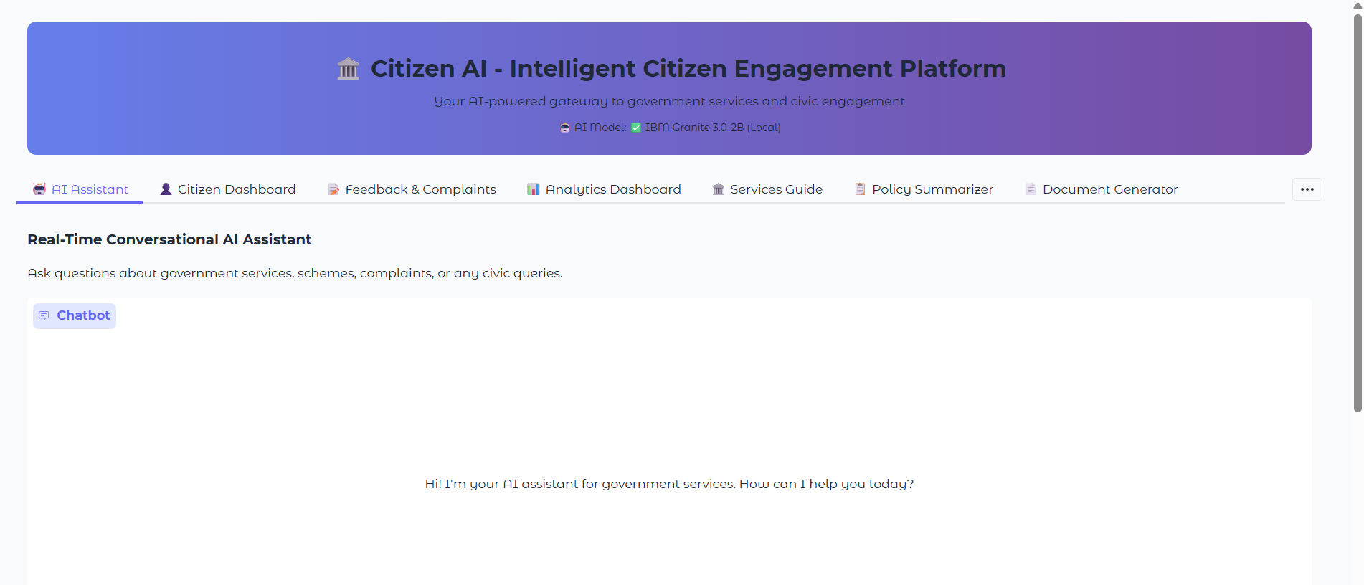

### Real-Time Corrections output:

### 

**Citizen dashboard:**

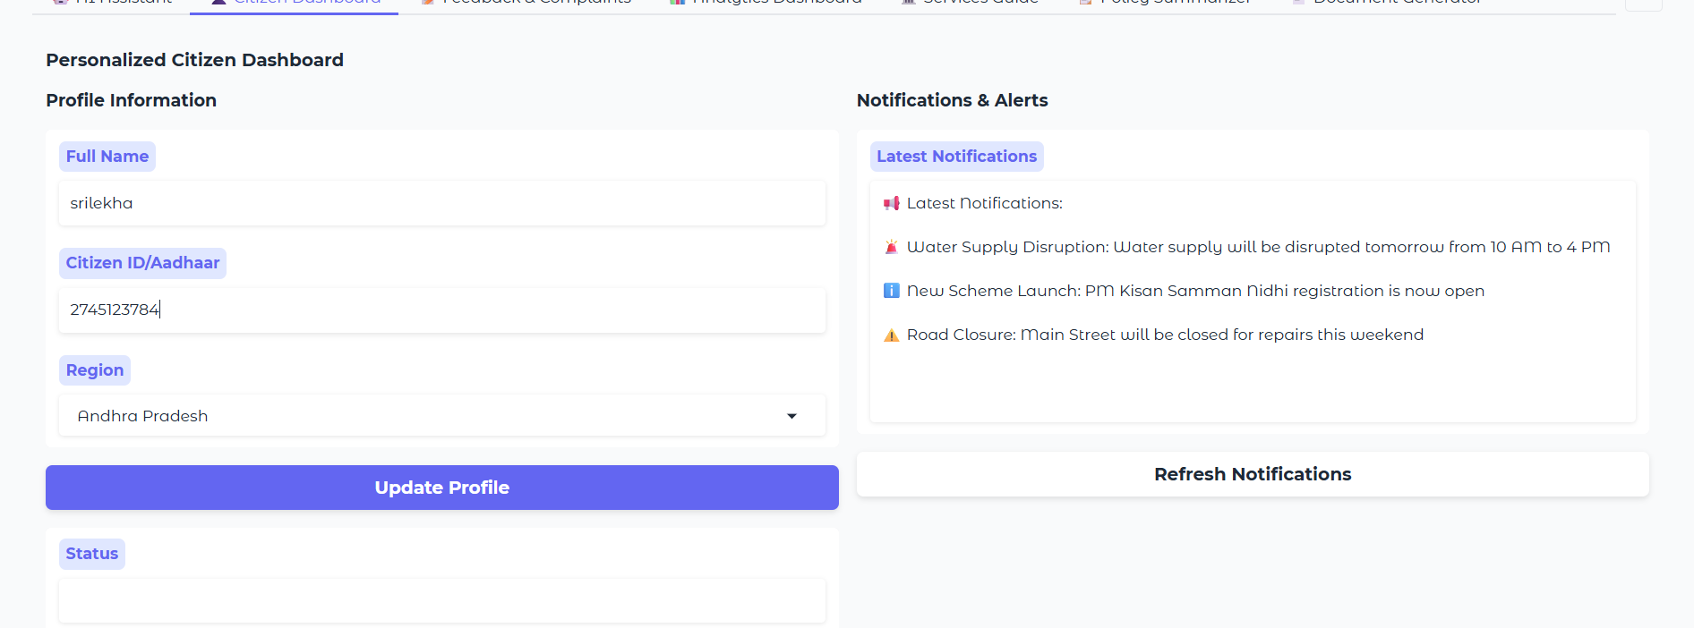

**Description:** The Citizen Dashboard is a personalized, real-time digital interface designed to empower individual users by giving them full visibility into their interactions with government services. It serves as the central hub of the Citizen AI platform, offering transparency, engagement, and actionable insights for every registered citizen.

### Feedback and complaints:

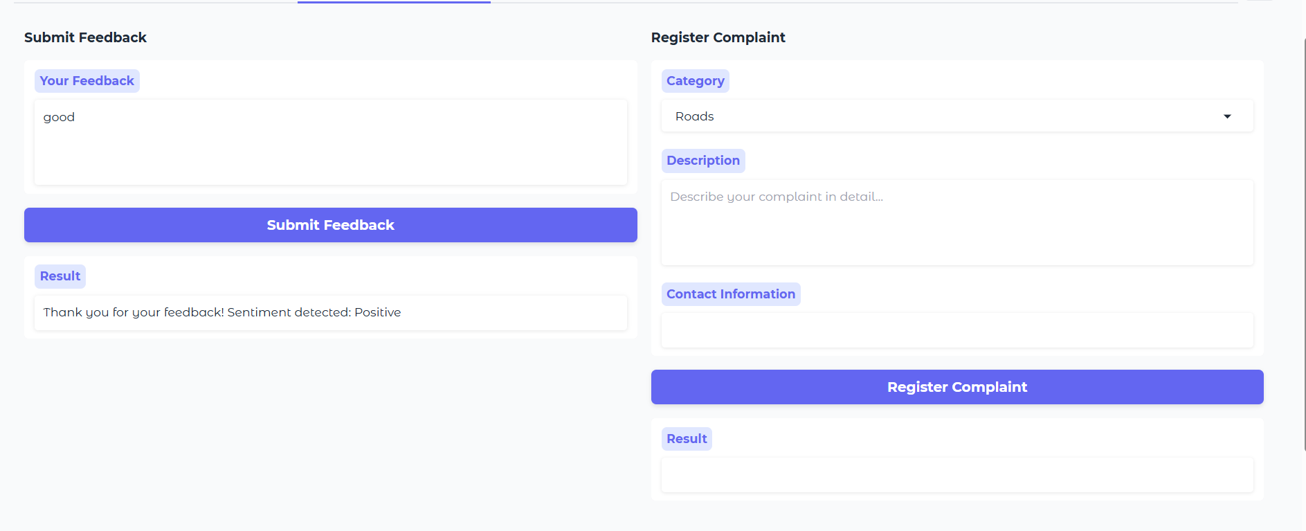

**Description:** The Submit Feedback and Complaints module in Citizen AI allows citizens to raise grievances and share feedback seamlessly, while the system automatically performs sentiment analysis on the submitted text. This feature not only helps citizens express their concerns clearly but also enables the government to understand public mood and urgency through AI-powered insights.

### Analytics Dashboard:

**Description:** The Analytics Dashboard in Citizen AI is a powerful visual interface designed for government authorities and administrators. It provides real-time insights into citizen interactions, service feedback, sentiment trends, and system-wide performance metrics. This dashboard transforms raw data into actionable intelligence for improving public services, policymaking, and citizen engagement.

### Service Guide:

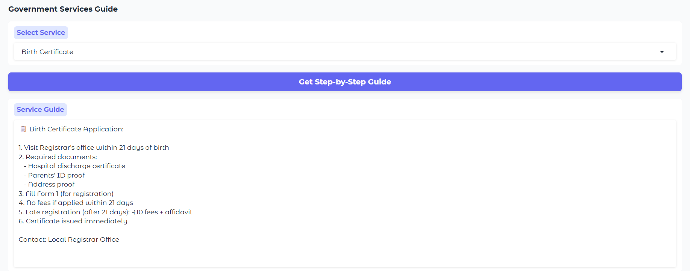

**Description:** The Service Guide in Citizen AI is an AI-powered navigational assistant that helps citizens access government services through a step-by-step, chat-like interface. It simplifies complex bureaucratic processes by offering clear, personalized instructions in multiple languages, making public services more accessible, inclusive, and user-friendly.

## 

## Conclusion:

The **Citizen AI – Intelligent Citizen Engagement Platform** is a transformative solution designed to bridge the gap between governments and citizens through the power of Generative AI. By integrating advanced AI models like **IBM Granite** with an intuitive and inclusive user interface, the platform enables real-time, multilingual interaction, transparent grievance redressal, and data-driven governance.

With modules such as the **Real-Time Conversational Assistant**, **Sentiment Analysis Engine**, **Dynamic Analytics Dashboard**, and **Personalized Service Guide**, Citizen AI empowers both **citizens** and **authorities** to engage in a smarter, faster, and more responsive civic ecosystem.

The platform not only simplifies access to public services but also strengthens trust in governance by promoting **accountability**, **transparency**, and **active public participation**. It’s designed with inclusivity at its core — supporting regional languages, accessibility features, and offline modes for rural or underserved populations.

As governments continue their digital transformation journeys, **Citizen AI stands as a scalable, secure, and citizen-first model** for smart governance. It sets a benchmark for how technology and empathy can come together to build a more informed, connected, and empowered society.